KID’S ZONE
Saturday, June 11, 2022
10:00 AM – 3:00 PM

Exhibitor Information & Registration Form

The 2022 Extreme Weather Ready Expo invites you to participate as an exhibitor in the Kids Zone. This family-friendly, free event will take place at the George R. Brown Convention Center. The Expo is scheduled for Saturday, June11, 2022 from 10:00 AM to 3:00 PM. The Kids Zone has an official opening kick-off set for 10:30 A.M. The wide variety of exhibitors providing disaster preparedness educational materials, together with the convenient location, is projected to attractive over 2,500 visitors. As always, there is no charge for exhibitor booth registration in the Kids Zone!

As Texans, we are all aware of the potential for many types of natural disasters in our great State – flash floods, hurricanes, windstorms, tornadoes and wildfires. Whether dealing with extreme weather events or any other type disaster, preparedness is a year-round activity. The Expo is an excellent way to promote your company’s commitment to the community while engaging visitors with the importance of disaster preparedness.
Supporting community disaster preparedness is a big part of the Expo’s take-away message. Visitors of all ages attend this highly interactive Expo to learn how to be better prepared as an individual or family for severe weather conditions. Discussions and exhibit booths provide an array of activities including, how to make a household emergency plan, demonstrations on how to build an emergency backpack and what items should be included in the kit, t important resources available in their neighborhoods (i.e., fire, police, city agencies, churches, temples) and much, much more.
EXHIBITOR GUIDELINES & INFORMATION
We request that you plan hands-on emergency preparedness activities for young visitors at your booth. To make your exhibitor booth matter, displaying information regarding your organization is also encouraged
Registering: Please complete the attached Kids Zone Exhibitor Registration Form no later than Friday, May 15th and return to Ryan.prillman@houstontx.gov.

Set-Up & Tear Down: Move-in for exhibitors will be from 3:00 PM to 6:00 PM on Friday, June10. Booths can also be set-up from 8:00 A.M. to 9:00 AM on Saturday, June11. Please do not start deconstruction and remove any display items, signage and materials from your booth prior to 3:00 PM.
Booths: Exhibitor booth registration includes the following:
- One 10’x10’ booth area
- One skirted table
- Two chairs
- Electricity
- Two lunch tickets per booth; and
- Pre-Expo marketing with company name placed on Extreme Weather Expo website promoting your involvement at the event and exhibitor presence in the Kids Zone.

Parking: For your convenience, there is metered parking on surrounding streets and pay stations at several adjacent parking lots. Unfortunately, there is no Expo parking available at the George R. Brown Convention Center.

Information: Additional Extreme Weather Ready Expo details: www.weatherreadyexpo.com.

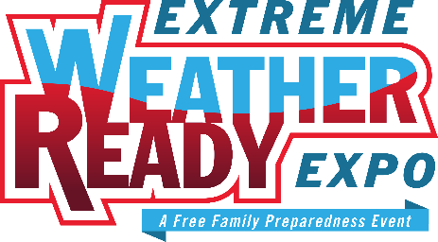 | KID’S ZONE  Saturday, June 11, 2022  10:00 AM – 3:00 PM

Exhibitor Registration Form

Organization Name: Click or tap here to enter text.
Mailing Address: Click or tap here to enter text.
Contact Person: Click or tap here to enter text.
Email: Click or tap here to enter text.
Office Phone: Click or tap here to enter text. Cell Phone: Click or tap here to enter text.
Number of Tables: Choose an item.
Number of Chairs: Choose an item.
Electricity Required: Choose an item.
Please provide your company’s disaster preparedness activity and any take-home materials provided: Click or tap here to enter text.
Questions: Ryan Prillman: 832-395-3775

Exhibitor Registration Deadline: Friday, May 20, 2022

Please return completed Kids Zone Exhibitor Registration Form to Ryan.prillman@houstontx.gov

Thank you and we look forward to seeing you at the
Extreme Weather Ready Expo!

